RECENTLY ACQUIRED SUGAR MILL IN NEED OF A STRATEGY TO ACHIEVE PRODUCTION OBJECTIVES

SNAPSHOT
Brazil is the world’s top producer and exporter of sugarcane. It supplies 50% of the world’s sugar, producing 654.8m tonnes of sugarcane, 41.25m tonnes of processed sugar and 29.7bn litres of ethanol annually.
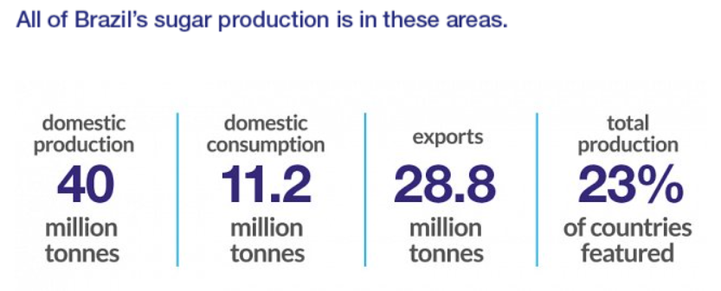

THE CLIENT
WILMAR INTERNATIONAL is a global leader in raw sugar producers, with operations in Australia, New Australia and New Zealand, Indonesia, Morocco, India, Myanmar, Brazil and China. This global network and integrated supply chain gives them a unique position as one of the world’s largest international traders of sugar.
They recently acquired ICUMSA a working sugar mill in Brazil as part of their expansion strategy, moving into American markets.
Currently this sugar mill produces 6 million tons of sugar, they plan to produce 12 million tons by 2024 and 14 million by 2026. To do so, WILMAR is re deploying assets from other sugar mills to ICUMSA, no new assets are being acquired.
This sugar mill is one of the oldest in Brazil, machines have been working for over 30 years
Oscar was the maintenance manager in another sugar mill from Wilmar, he was brought to ICUMSA to replicate his previous success, he managed to turn a sugar mill with 80% unplanned corrective maintenance in two years, achieving 9% uptime and reducing 18% in maintenance costs.
Oscar’s first audit of ICUMSA maintenance strategy reported 90 – 95% of all maintenance activities are related to corrective maintenance. 2 of every 3 assets fail due to lubrication related incidents, contamination control is the biggest issue. During his first weeks he noticed several unattended oil leaks affecting assets down the line no one from the technical staff seemed worried about the consequences.
Failure is assets is an everyday problem, even more now they are bringing equipment from the other sugar mills, infant mortality is occurring on 2 out of 3 assets commissioned, bearings are replaced continuously and
Oscar mentions his aim is to bring the sugar mill to a TPM standard, that is the final goal.
Corporate works with SAP PM as their CMMS in more mature plants, Oscar plans to have it up and running before the end of this year ensuring they are aligned with every other plant in the group.
Their team is formed by 4 maintenance chiefs with 3 supervisors each,
Sugar mills have a very special condition, most countries where sugar cane is grown just like Brazil have a fertile soil that produces sugar all year, nonetheless there is a seasonal period, where productivity drops, so it is the best stage of the harvest to carry out maintenance in sugarcane mills.
Crop and off-season periods in ethanol and sugar mills
In Ethanol and Sugar mills, it is quite common for the harvest to start in May and may last until November. After this period, another so-called off-season begins, which in ethanol and sugar mills usually takes place between December, and may last until April.
SUGAR CANE CROP IN BRAZIL – April to November
BETWEEN SEASON - December to March
The off-season takes place in the period before the harvest, and it is at this stage that a series of maintenance is carried out at the ethanol and sugar mills, including preventive maintenance in:
• Steam turbine
• Speed reducer
• Thermoelectric plants
• Parts
• Accessories
• Components
Any unscheduled stoppage in the industry, will result in a loss of profit. “Sugar cane, which is the raw material used by the mills, is perishable and has a set time to go to crushing”, he explains.
Maintenance during the off-season is essential to ensure the productivity and competitiveness of the sugarcane industry.
That means that sugar mills have a strong rooted culture of running to failure, they’ll work their assets closely to failure because they have a programmed outage and overhaul stop yearly.
SUMMARY
1 maintenance manager
3 maintenance engineers
3 maintenance chiefs
9 maintenance supervisors
80 maintenance technitians
Plans to double production in 2 years

ASSIGNMENT QUESTIONS
Is training the best option to reduce unplanned failure?
How can you ensure that training will have the expected result?
Can mature implementation be achieved during repair period?
Where should implementation start?
What are the highest priorities?

